

**ETHEREUM BEHAVIORAL DESIGN PATTERNS –**

**PROXY DELEGATION WITH ETERNAL STORAGE**

Date: 12/05/2018

Brent Anthony Tudas

Sandra Alleine Blanca

Jaymar Dingcong

Robert Aries Dela Paz

Kimberly Mae Reyes

Patrick Oliver Palmero

**INSTRUCTIONS**

It is not adviceable to deploy this contract since this runs some assembly code that might cause your machine to malfunction.

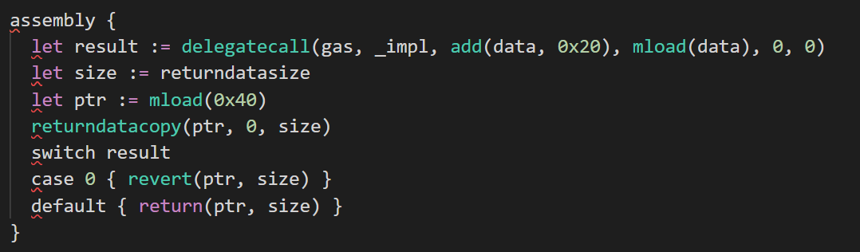

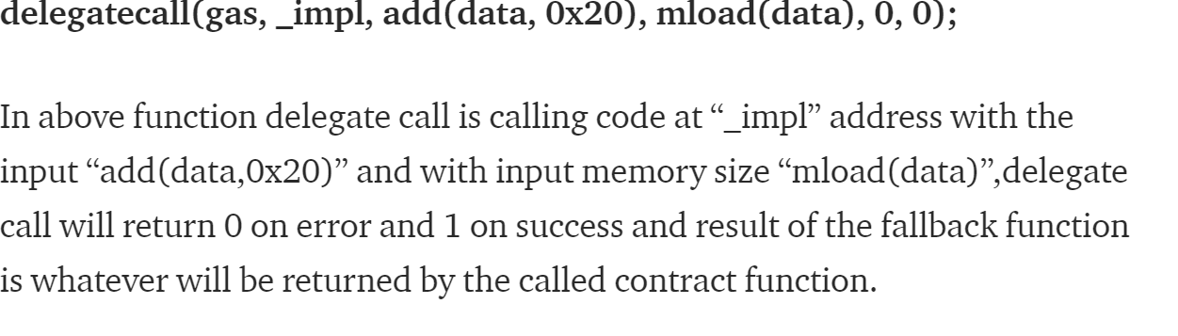

**Proxy Contract**

Contains the state which will be modified

**Delegate Contracts**



Contains the logic to be followed by the proxy contract. These can be continuously upgraded.

**Key Storage Contract**

Common storage for all storage state variables which will be shared among all versions of smart contracts.

**Workflow Diagram**

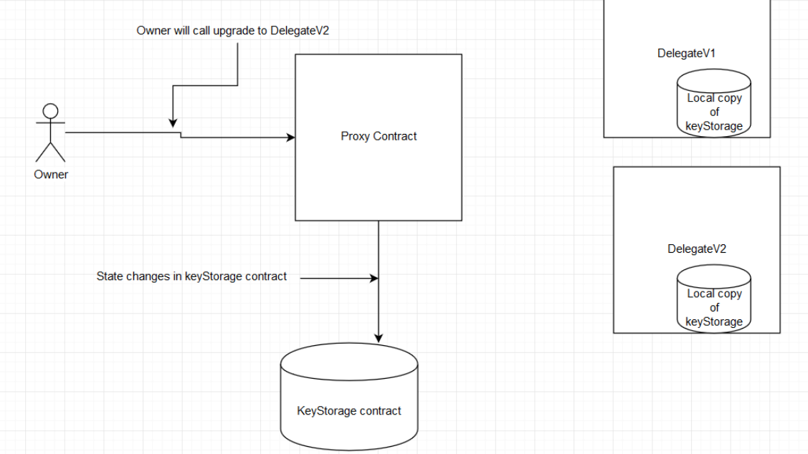

Call upgrade to DelegateV2

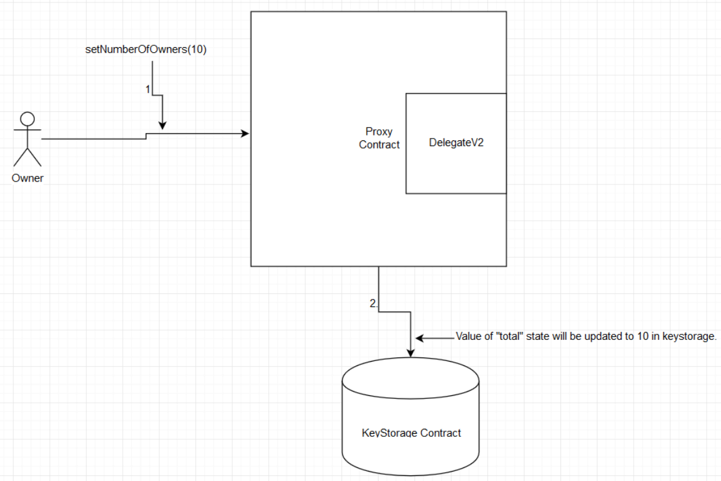

**References:**

**Upgrading Deployed Smart Contracts -**

[**https://medium.com/quillhash/how-to-write-upgradable-smart-contracts-in-solidity-d8f1b95a0e9a/**](https://karl.tech/learning-solidity-part-2-voting/)